PHOTOSHOOT CALL SHEET

Client: | Spendmore Shopping Centre
Campaign: | Christmas 2014 Photography
Photographer: | Gina Milicia
Location:
Parking: | Metered street parking  (recommend to bring coins – approx $3 p/h)
Date: | Wednesday 10th September 2014
Call Times:  (everyone is  required on set) | 8.15am Photographer, H&MU, Stylist, arrive to set up  8.30am Client & Agency arrive  8.30am Kerry arrive for H&MU  8.30am Santa arrive for wardrobe & H&MU  9am Jenny arrive for H&MU  9.45am Peter arrive for H&MU  9.15am – 9.45am SHOT 1 (30mins):  Santa photos (Kerry & Santa)  10.15am – 12.15am SHOT 2 (30mins per shot)  “couple shots with Jenny and Peter”  - Gift Guide  - Trading hours  - Gift wrapping  - Gift Card  - 12 days of Christmas  < 12.30pm – 12.45pm lunch break >  < Jenny,Peter & H&MU wrap >  1.30pm – 2.15pm (still life)  Christmas pudding  < Approx wrap 2.30pm 3pm >
Attendees: | James Brown (agency) 0411 1234  Penny Lane (agency) 0422 666 222  Justin doit (agency) 0432 333 123  Iwana Spundoola (client) 0416 888 777  Kurt Kerching (client) 0412 444 333  Shome Damoney (client) 0401 000 999  Gina Milica (photographer) 0412 333 111  Johnny Blowout (Hair & Make Up) 0402 155 000  Rachel Zoe (Stylist) 0418 100 444  Talent:  Jenny Beautiful 0402 064 034  Peter Handsome 0413 239 022  XXXXXXX (santa) 04xx xxx xxx
Props & Wardrobe: | - Wardrobe, props etc to be supplied by Stylist  - Santa costume being supplied by talent  - Pudding being supplied by client
Meeting Place: | At Studio
Comments: | Talent, please ensure you do not wear hair product or any make-up prior to arrival

MAP VIEW

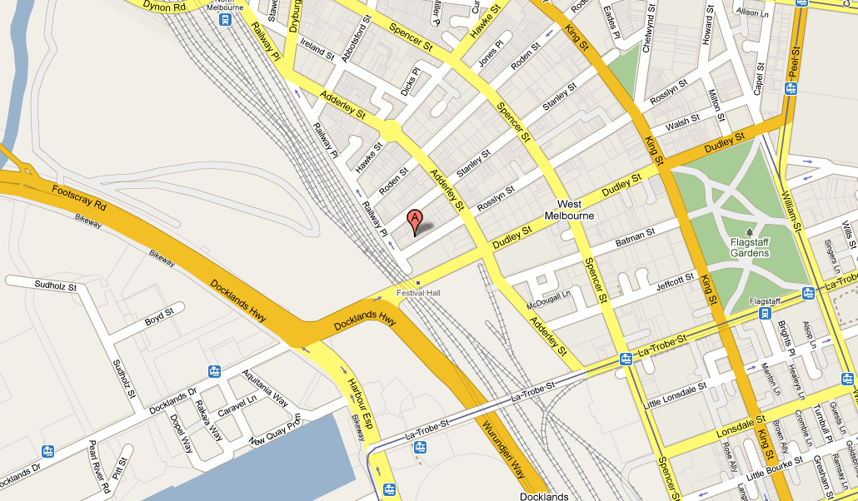

STREET VIEW

